**MoS - English communication stream**

**Lab 1: Comparison of time constants**

**Instructor**: Kjell Karlsson

**Experiment date**: 2018-11-29

**Submission date**: 2018-12-10

## **1** Introduction

To understand the behaviour of a system, we analyse the time constant. The time constant is defined as the time it takes for the system to reach 63% of its final value. These specifications are often given by the manufacturer in data sheets. However, the time constant can also be determined by looking at the step response of the system using a simulation software or computed analytically for a first order system. The system will be designed using a bond graph which is a graphical representation of a physical dynamic system.[1] It allows the conversion of the system into a block chart which will be used in this lab.

The purpose of this lab is primarily to compute and compare the time constants given by the different methods. There is a limit on which constants can be computed. For analytical computation, the time constant for whole DC motor cannot be solved as a first order system. Therefore, it is not a part of this lab. The specifications of the system only refer to the time constant for the whole DC motor and the electrical part.

## **2** Method and Materials

Here, a model of a DC motor was implemented using two different simulation software. Both tools should give the same results. The DC motor consisted of a mechanical and an electrical component. Each component was defined by a time constant. The whole system was also characterised by a time constant.

* **Whole DC motor**: $τ_{tot}$
* **Electrical part: $τ_{e}$**
* **Mechanical part: $τ_{m}$**

Before implementing the different methods, a bond graph of the system was designed. This is illustrated in *Fig.1* using one of the simulation software.

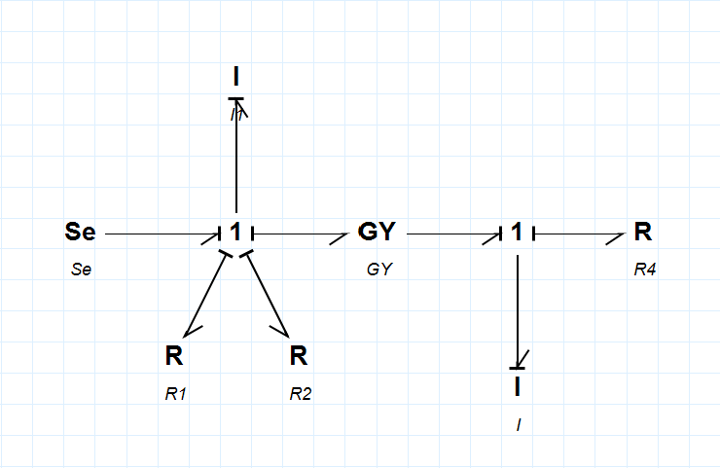

Figure 1: Bond graph of the DC-motor (20sim)

**2.1 Data sheet**

The data sheet provided by the manufacturer included the time constant for the whole system, $τ_{tot}$ and the electrical part, $τ_{e}$. This was noted for later comparison.

**2.2 Simulation**

For the simulation, two simulation software was used, 20 Sim and Simulink. The major difference in these two simulators is that 20 Sim use a bond graph representation while Simulink only accepts block charts. Since the bond graph from Fig.1 was already designed, it was easily implemented into 20 Sim. The bond graph can also be converted to a system of block charts using Eq.9 to Eq.17 (one equation was implemented as one block). In Fig. 2, the following block chart was designed and implemented in Simulink.

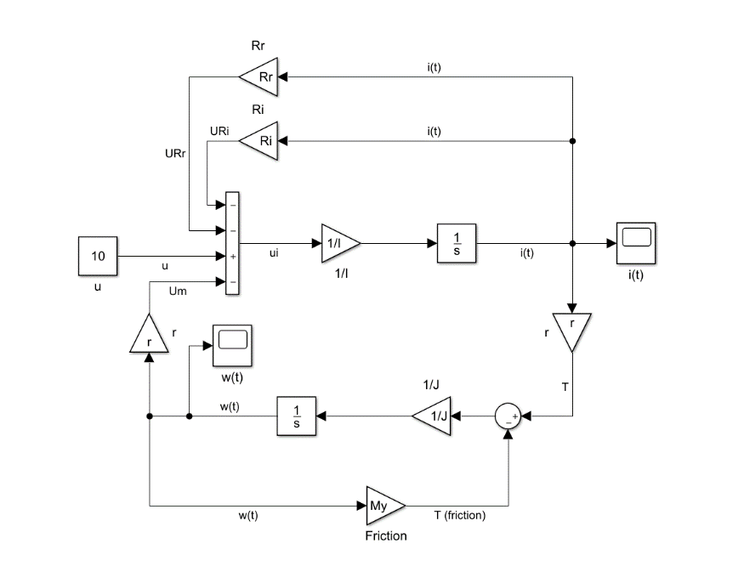

Figure 2: Simulated through block chart on Simulink

Firstly, the time constant ($τ_{tot}$) for the whole system was computed. This was done by analysing the plot of the step response for the output. In this case, the output was $ω(t)$. The time constant in a step response for a first order system was defined as the time it takes for the system to reach 63% of the final value. Secondly, to compute the time constants for the electrical ($τ_{e}$) and mechanical part ($τ_{m}$), some parts of the bond graph and blocks from the block chart were removed. These time constants were then computed the same way as for $τ_{tot}$. *Fig.3* illustrates a plot of a step response

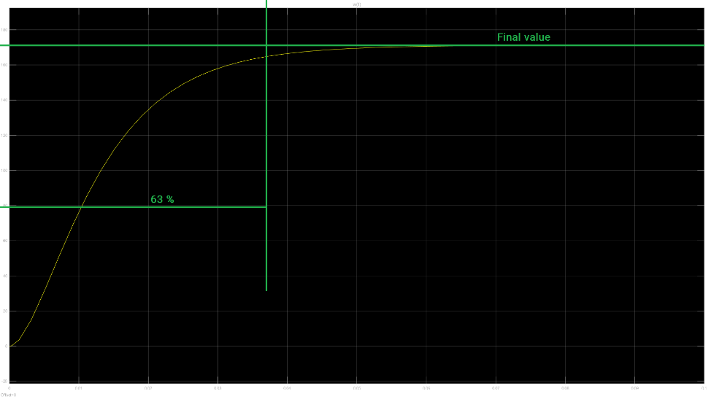

Figure 3: Example plot of the step response (yellow line).

**2.3 Analytical computation**

To compute the time constant for the electrical and the mechanical part, the system was divided into each subsystem. Since each part could be described by a first order system, the transfer function of each subsystem would be characterised as in *Eq.1,*

$G\left(s\right)=\frac{k}{sγ+1}$**(1)**

where $k$ is a constant and $γ$ is the time constant.

Through the modelled bond graph of the system (shown in *Fig. 1*), the governing equations were determined. See *Eq.9* to *Eq.17* in *Appendix A* for the following equations. These equations were used to solve each transfer function.

$G_{el}\left(s\right)=\frac{I(s)}{U(s)}$**(2)**

$G_{me}\left(s\right)=\frac{ω(s)}{M(s)}$**(3)**

*Eq.2* is the transfer function of the electrical part and *Eq.3* describes the mechanical. As mentioned above, the governing equations solved from the bond graph corresponds to the variables contained in these transfer functions. Therefore, the computation was nonetheless than a simple algebraic operation.

$G_{el}\left(s\right)=\frac{1}{R_{r}+R_{I}}*\frac{1}{s\left(\frac{I_{I}}{R_{r}+R_{I}}\right)+1}$**(5)**

$G_{me}\left(s\right)=\frac{1}{μ}*\frac{1}{s\left(\frac{J}{μ}\right)+1}$**(6)**

At this point, it was clear to see what each time constant was. Since the time constant was defined as the variable, $γ$ from *Eq.1*, the time constant for *Eq.5* and *Eq.6* was,

$τ_{e}=\frac{I_{I}}{R_{r}+R_{I}}$**(7)**

$τ_{m}=\frac{J}{μ}$**(8)**

where $I_{I}$, $R_{r}$, $R_{I}$, $J$, $μ$ are constants that was found in the data sheet provided by the manufacturer (see *Table 2* in *Appendix A*).

## **3** Results

With the provided constants and input value in each simulator, the respective time constant could be found, as shown in *Table 1*.

Table 1: Resulting time constants for each method

|  |  |  |  |
| --- | --- | --- | --- |
| Time Constant | Data sheet | Analytical | Simulation |
| $τ_{e}$*(ms)* | 2.95 | 2.94 | 2.97 |
| $τ_{m}$*(ms)* | X | 326 | 324.13 |
| $τ_{tot}$*(ms)* | 10.2 | X | 14.31 |

## **4** Discussion

From what can be seen from our results in Table 1. The time constant for the electrical part is small. This is understandable because the current flows quickly in an electrical system. However, for the mechanical part, the time constant is large which is caused by mechanical constraints such as friction.

Overall, the error for the time constant computed through the different methods is minor. The difference in $τ_{e}$ for the different methods is an error of 0.01 *ms*. For $τ_{m}$, the error is slightly larger, reaching an error of 1 *ms*. Lastly, the time constant for the whole system $τ_{tot}$ also has an error of 1 *ms*.

These errors are relatively minimal which is great. However, from what can be seen in Table.1, the

data sheet only provides the time constant for the electrical and the whole system while the analytical

method provides with the time constant for the electrical and the mechanical part. The advantage

with designing a model and using a simulation is that the simulator can compute all of these time

constants with great accuracy and speed. The disadvantage of using a simulator is that it must be

done with care depending on the system’s complexity and the method simulators use for computing

the time constant.

## **5** Conclusion

As mentioned in section *4. Discussion*, data sheet and analytical method has limitations and cannot compute all the time constants. However, through simulation, it was possible to compute and analyse all time constants. If not, we would recommend the simulation for future computation. Although the simulator computes the values with a minimal error, we have no way to know if the values are expected without comparing them with the data sheet or analytically. To summarise, future computation of time constants for new systems could be done with two methods so that it can be compared and validated. If the time constant for the different methods has offsets, an average value could be computed from the two methods. If the system is too complex to be analysed by hand, a simulator would be a better option to use.

Appendix A

Table 2: Constants for the DC motor

|  |  |
| --- | --- |
| Rr (Ω) | 0.35 |
| Ri (Ω) | 0.8 |
| Ii (H) | 3.39E-03 |
| µ (Nms/rad) | 1.19E-04 |
| r | 0.056 |
| J (kgm^2) | 3.88E-05 |

The equations below describe each part of the bond graph illustrated in *Fig.1.*

$S_{e}: u (input)$**(9)**

$s_{1}: u_{I}=u-u_{Rr}-u_{RI}-u_{m}$**(10)**

$s_{2}: T_{J}=T-T_{µ}$**(11)**

${R:R_{r}: u}_{Rr }=R_{r}*i\left(t\right)$**(12)**

${R:R_{I}: u}_{RI }=R_{I}*i\left(t\right)$**(13)**

${R:µ: T_{µ}}_{ }=µ*ω\left(t\right)$**(14)**

$I:I_{I}: i\left(t\right)={\frac{1}{I}}_{I}* \int^{t}{u_{I}\left(τ\right)dτ}$**(15)**

$I:J: ω\left(t\right)=\frac{1}{J}* \int^{t}{T_{J}\left(τ\right)dτ}$**(16)**

$T\left(t\right)=r*i(t)$ $u_{m}=r* ω(t)$**(17)**

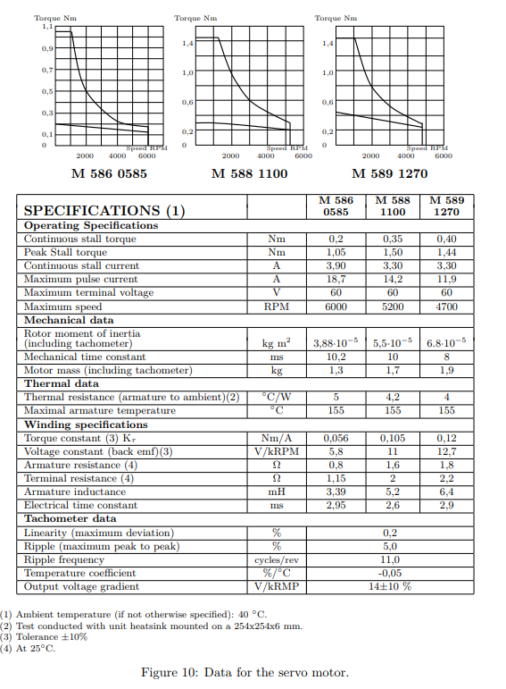

Figure 4: Provided data from the manufacturer for the DC motor

1. En.wikipedia.org. (2018). Bond graph. [online] Available at: https://en.wikipedia.org/wiki/Bond_graph [Accessed 2 Dec. 2018].